

|  |  |
| --- | --- |
| **Project_Bookstore_C2110L_Group01** | |
| Author | 1. Do Thai Anh 2. Phung Quang Thanh 3. Nguyen Quang Du |
| Date | August 16, 2022 |
| Instructor | Mr. Diep Tran Van |

**Index**

1. **PROBLEM DEFINITION………….……………………………………………………3**
   1. **Problem Abstraction………………………………………………………….……...3**
   2. **The Current System………………………………………………………….………3**
   3. **The Proposed System……………………………………………………….………..3**
      1. **Boundaries of the System…………………………………………….……….3**
      2. **Hardware and Software Requirements…………………………….………..3**
2. **CUSTOMER REQUIREMENTS SPECIFICATION………………………………….3**
   1. **Users of the System…………………………………………………………….……..3**
   2. **System Functions…………………………………………………………….……….3**
      1. **Main Page…………………………………………………………….………..4**
      2. **Admin Page……………………………………………………………………5**
3. **SYSTEM DESIGN………………………………………………………………………..6**
   1. **Entity Relationship Diagram……………………………………………….………..6**
   2. **Database Design……………………………………………………………………...6**
   3. **Sitemap……………………………………………………………………………….6**
      1. **Main Page……………………………………………………………………..7**
      2. **Admin Page…………………………………………………………….…….16**
4. **TASK SHEET……………………….…………………………………………….……..19**
5. **PROBLEM DEFINITION**
   1. **Problem Abstraction**

* Bookstore North Hills is a website that sells books, including all kinds of books to suit all your reading needs.
* The site also has a wide range of featured and latest books on the market.
* More specifically, the website has full features such as accounts, many payment methods for all customers
* The website is to be developed for the Windows Platform using HTML5, Javascript and Geolocation. The site should work well in all leading browsers including Chrome, IE, Firefox etc.
  1. **The Current System**
* To introduce products, reach many customers and receive customer information remotely, the company is in dire need of a system that can perform those tasks, while building a website is one of the effective ways the best
  1. **The Proposed System**

The new system is a simple website that includes:

* **Products, Categories pages:** Introduce all products, categories.
* S**tore Location:** Show contact info.
* Phone number.
* Store address with Google Maps.
* **Catering, Franchising, Feedback forms:** receive and view customer information and potential partner information.
* **About us:**
* Introduction about the company.
* Contact information.
  + 1. **Boundaries of the System**
* The website does not have full functions of an e-commerce website like Customers’ account, Cart, Online order…
* For interacting with customers, the website’s functions are to display current products and to receive information under forms only.
  + 1. **Hardware and Soft ware Requirements**
* **For customers:**

PC, laptop, tablet, smartphone with browser that can support HTML5, CSS, Javascripts and PHP such as Google Chrome.

* **For company:**
* Software:
  + - Browser supporting HTML5, CSS, Javascripts and PHP.
    - A suitable PHP version, XAMPP and MySQL.
    - Windows 10 or above.
* Software:
  + - PC, laptop with minimal screen of 1024px.
    - Double Core processors or higher.
    - RAM of 1GB or higher.
    - Free disk space of 120MB or higher.

1. **CUSTOMER REQUIREMENTS SPECIFICATION**
   1. **Users of the System**

* **Customers:** Those who wants to browse products and order through phone, request catering services, offer co-operation opportunities.
* **Company:** Those who have responsibilities of colecting, analyzing, and precess data. After processing and string data on external paperworks/programs, users will have to clean input data by deleting contact information in Admin pages.
  1. **System Functions**
     1. **Main Page**
* **Header – Menu bar:**
  + Log in: top left, clickable link to form login
  + Logo: next to log in, clickable link to homepage.
  + Menu:
    - Index: clickable link to homepage
    - Products: links to all-categories page, auto select form SQL.
      * Category list: links to All-product-by-type page.
      * Product list: links to Product-detail page.
    - Blog: links to blogpage.
    - Feedback: input form customers feedbacks.
* **Footer:**
  + Social media buttons: links to Facebook, Youtube, Instagram…
  + Email information: clickable that invokes the local mail client.
  + Phone number: clickable button.
* **Homepage:**
  + Banner (1 image only).
  + About us
  + Featured products
    - Button link to all-product-by-type page.
    - Sidebar product.
  + Contact form
  + Slide
  + Follow us
  + Maps
* **All categories page:**
  + Linked form Menu (“Sản phẩm”,”Blog” button)
* **Single category page (all-product-by-type)**
* **Single Product page (product-detail)**
  + 1. **Admin page**
* **Menu**
  + - * Dashboard: show existing users.
      * Category: list all categories, add new, edit, delete buttons.
      * Product:
        + List all products, add new, delete buttons.
        + Dropdown: all-product-by-type.
      * Catering: list all catering service request contact information.
        + Name, phone, email, datetime, event address, notes.
        + Delete button: used after precessed and stored data to external paperwords/programs.
      * Franchising
        + List all partnering registration information.
        + Delete button: used after processed and stored data to external paperworks/programs.
      * Customer Feedbacks:
        + List all feedbacks from customers with title, contact info.
        + Delete button: used after processed and stored data external paperworks/programs.
        + Open Website: open Homepage of website in new tab.

1. **SYSTEM DESIGN**
   1. **Entity Relationship Diagram**

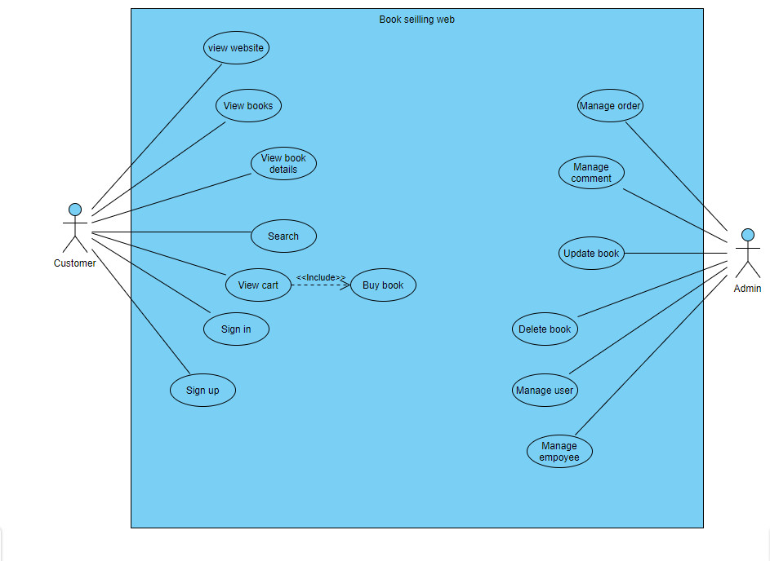

* 1. **Database Design**
  2. **Sitemap**
     1. **Main Page**
        + **Homepage**

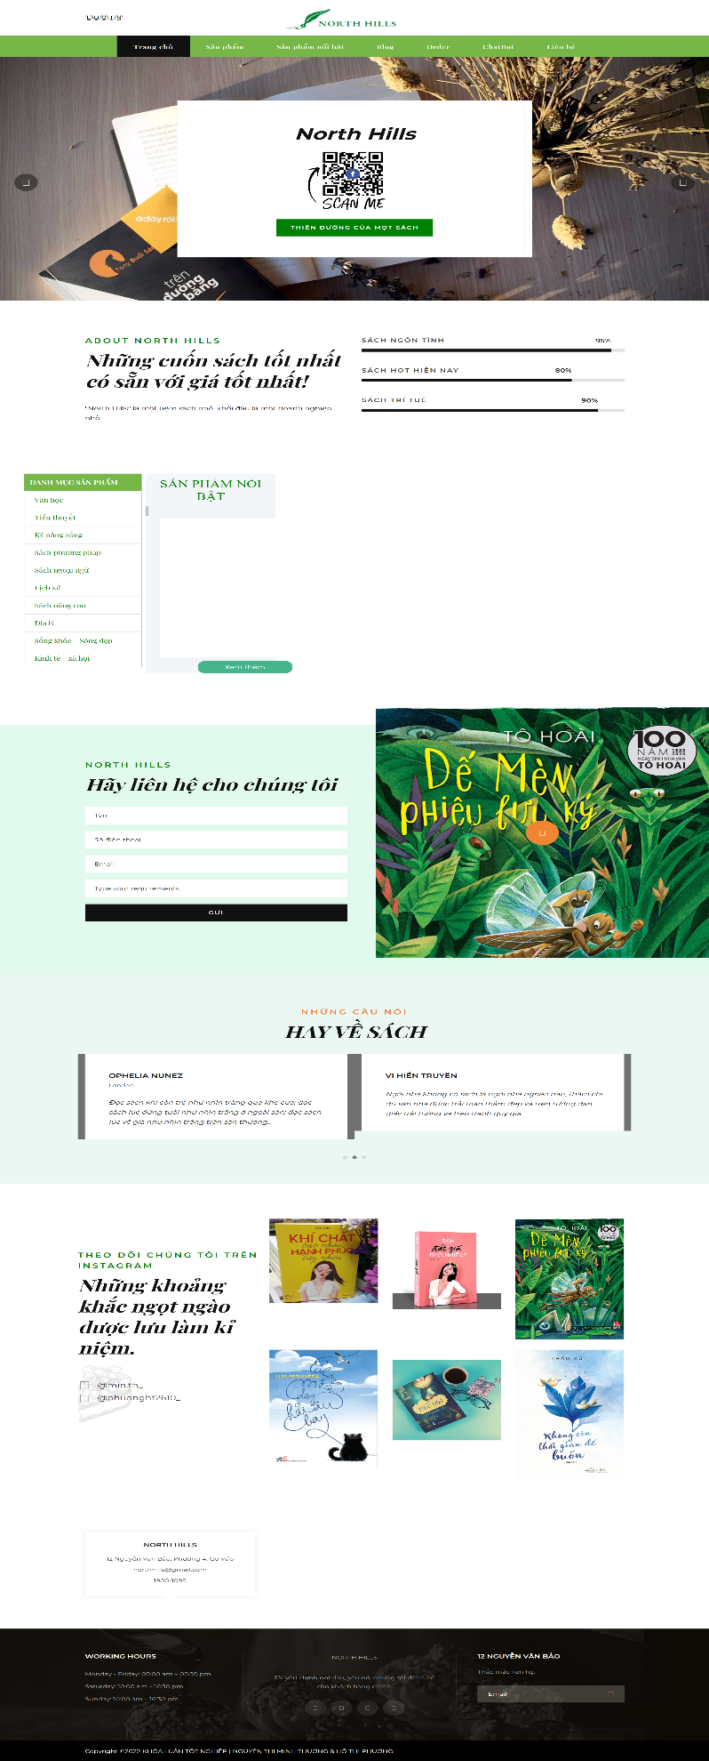

* + - * **Product page**

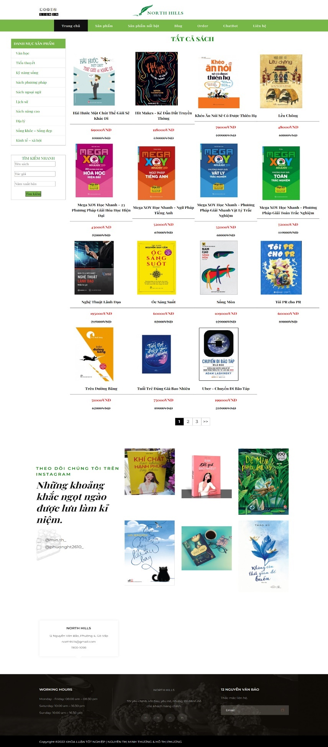

* + - * **Detail Product**

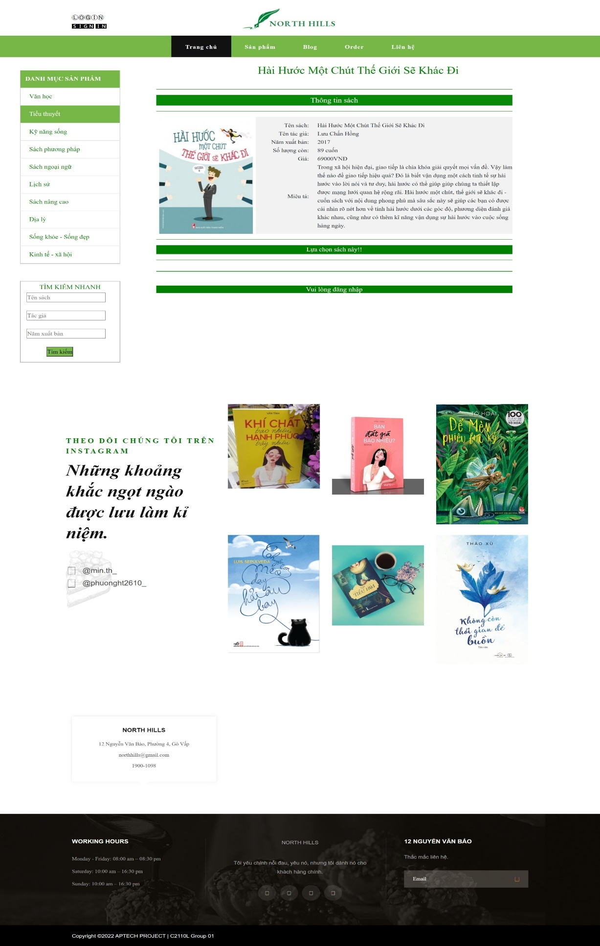

* + - * **All category page:**

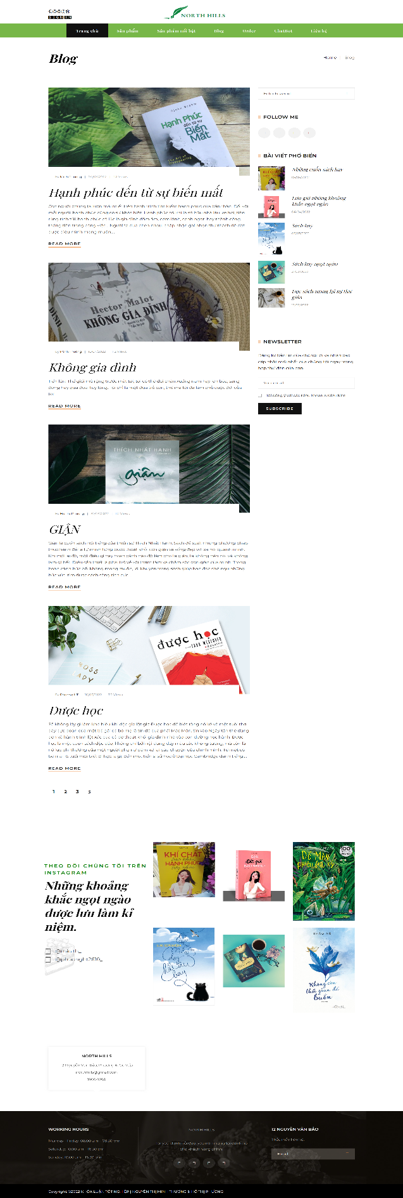

* + - * **Contact:**

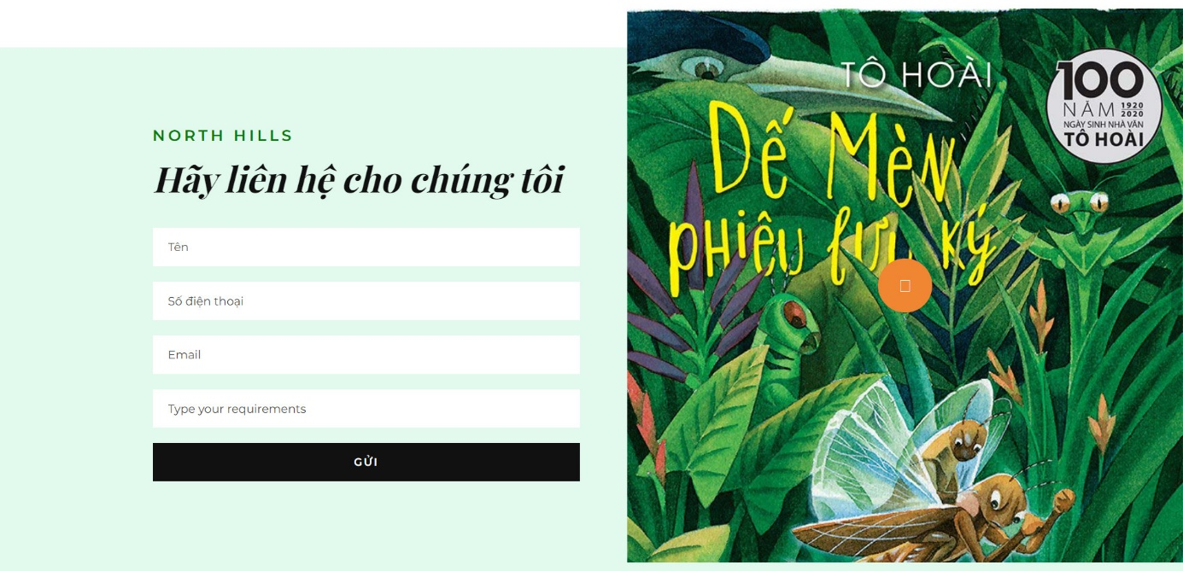

* + - * **Sign in:**



* **Product import**

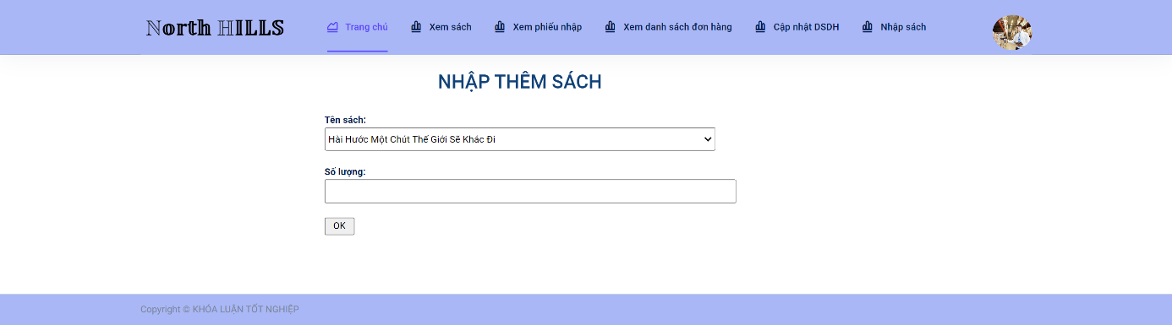

* **Order check**

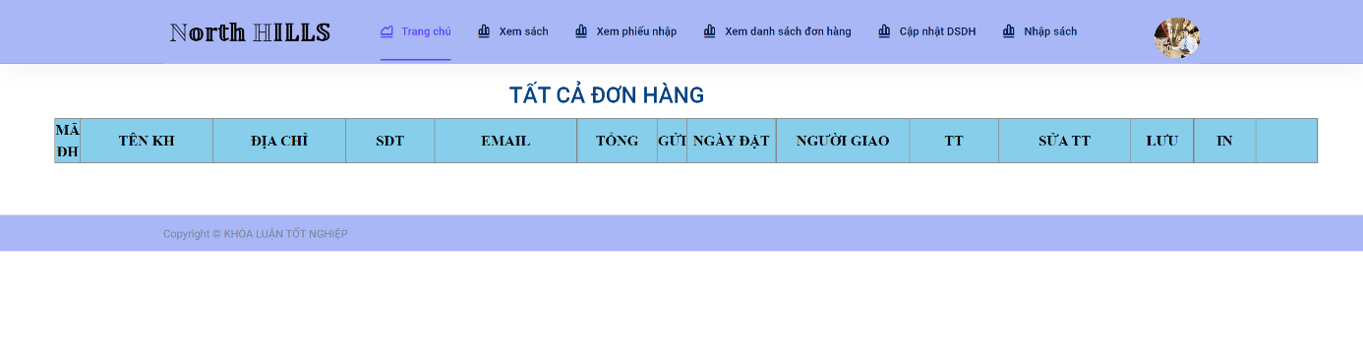

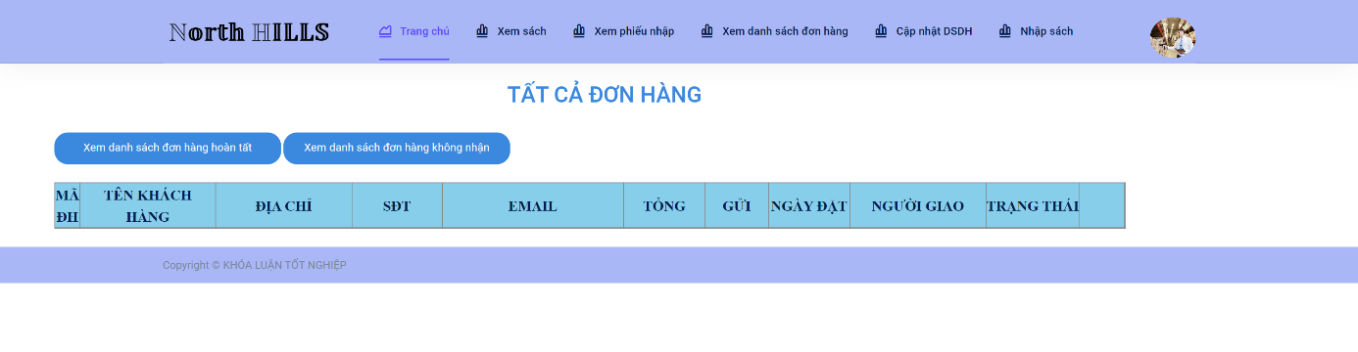

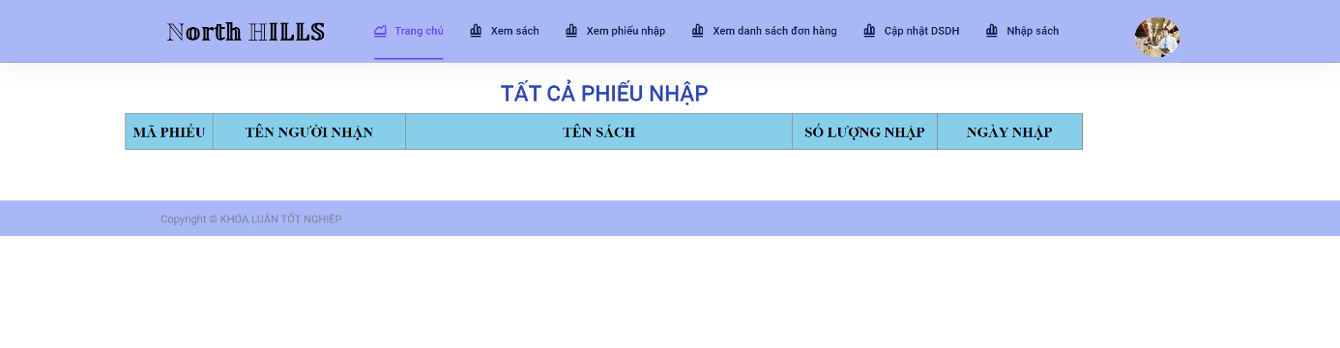

* + - * **Sign up:**

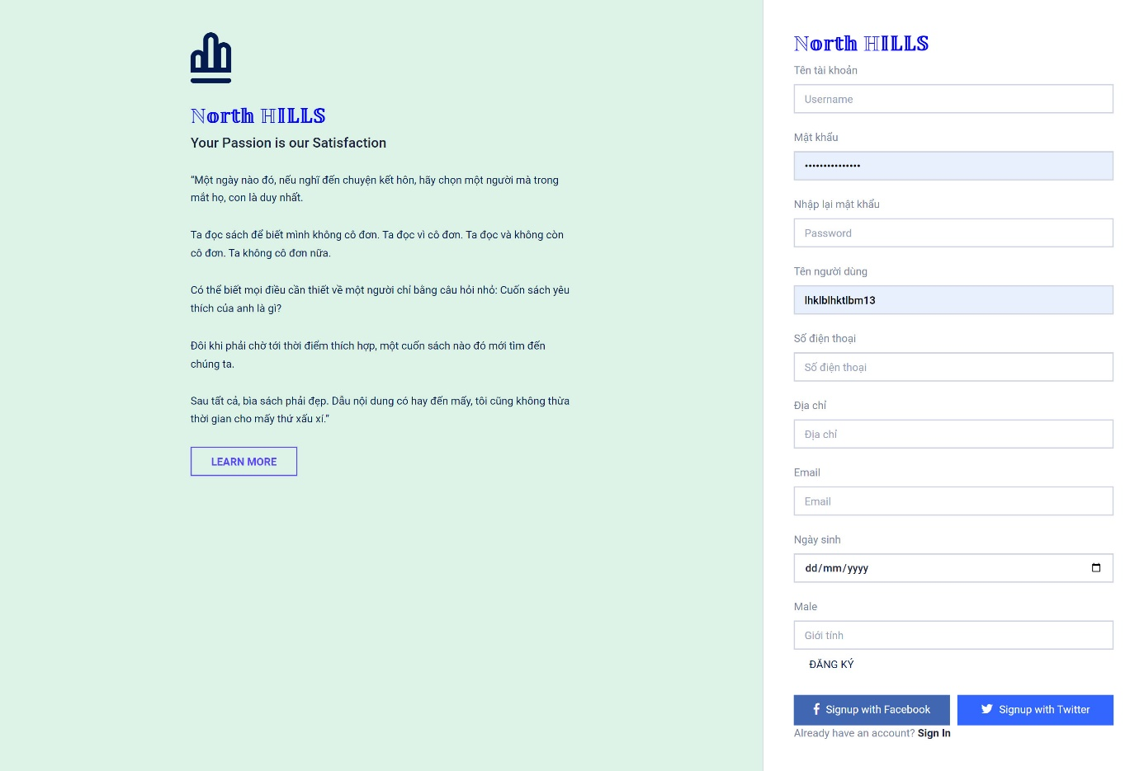

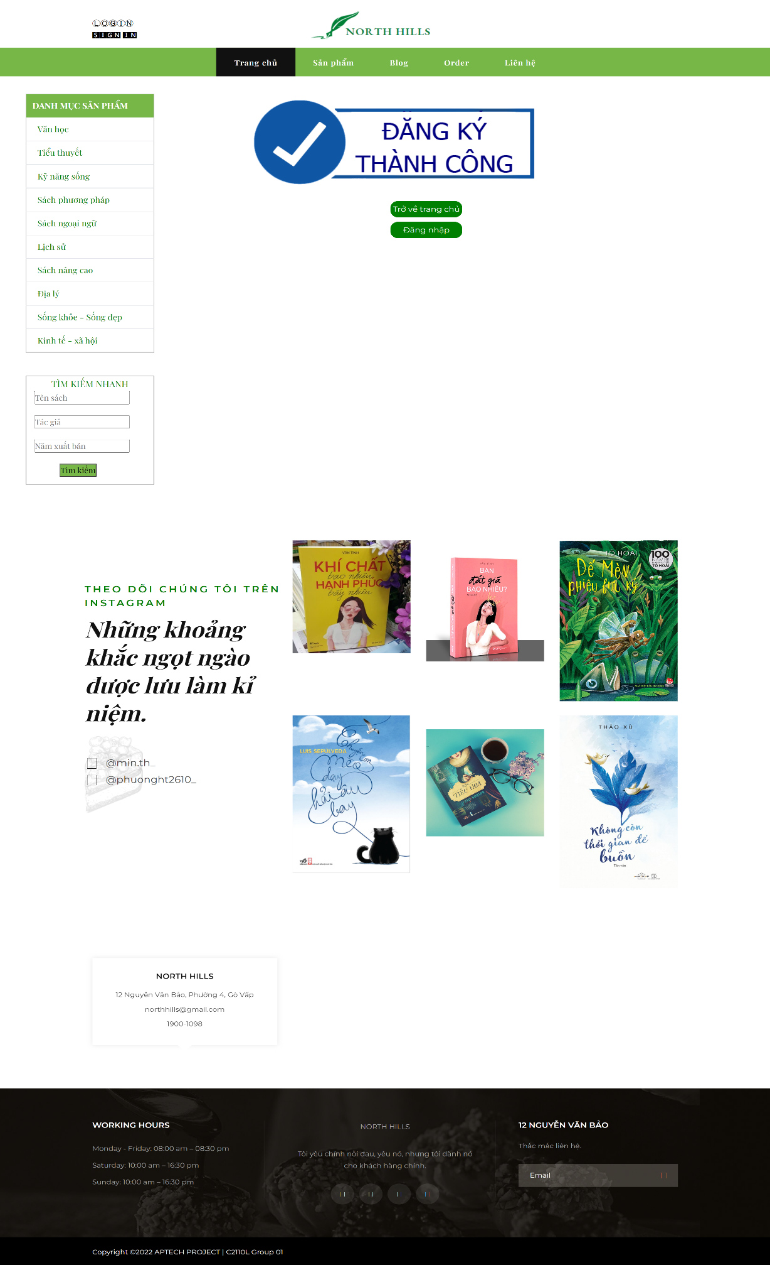

* + 1. **Admin Page**
       - **Username: admin**
       - **Password: admin**
       - **Publisher list**

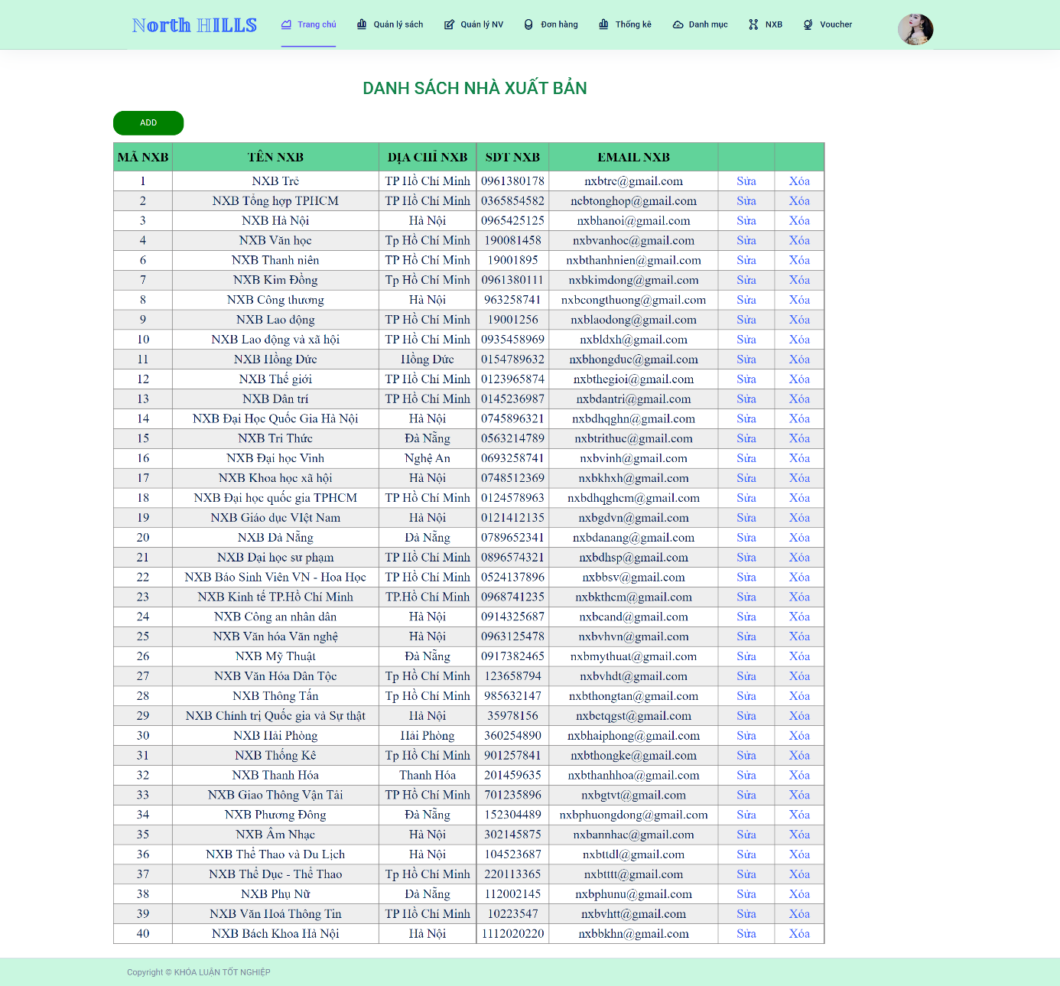

* + - * **List files**

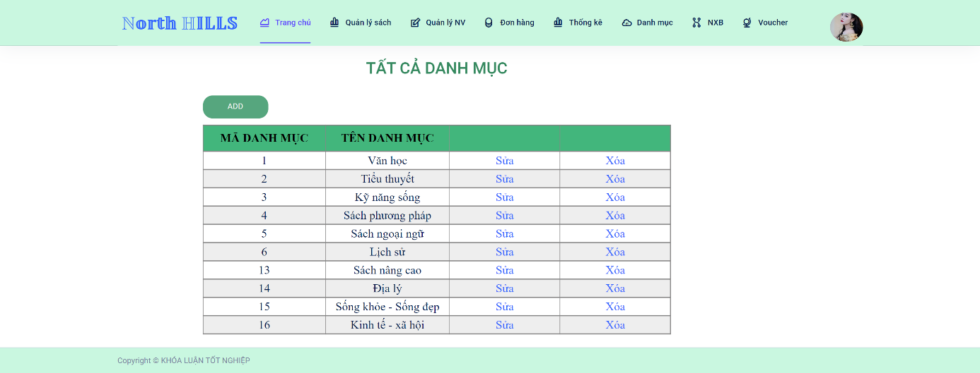

* + - * **All orders**

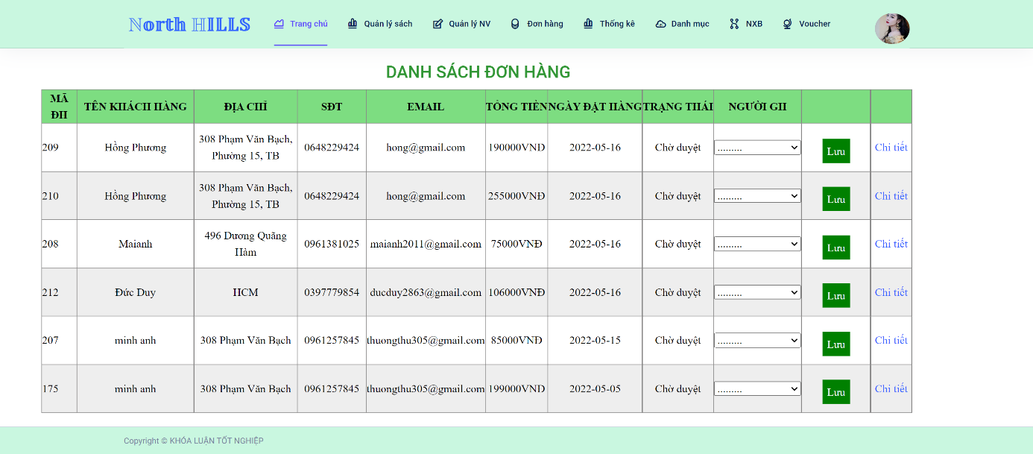

* + - * **List staff**

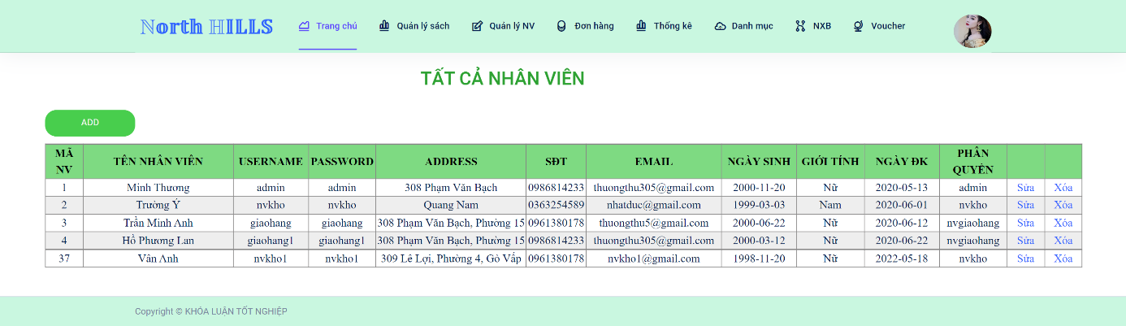

* + - * **List book titles**

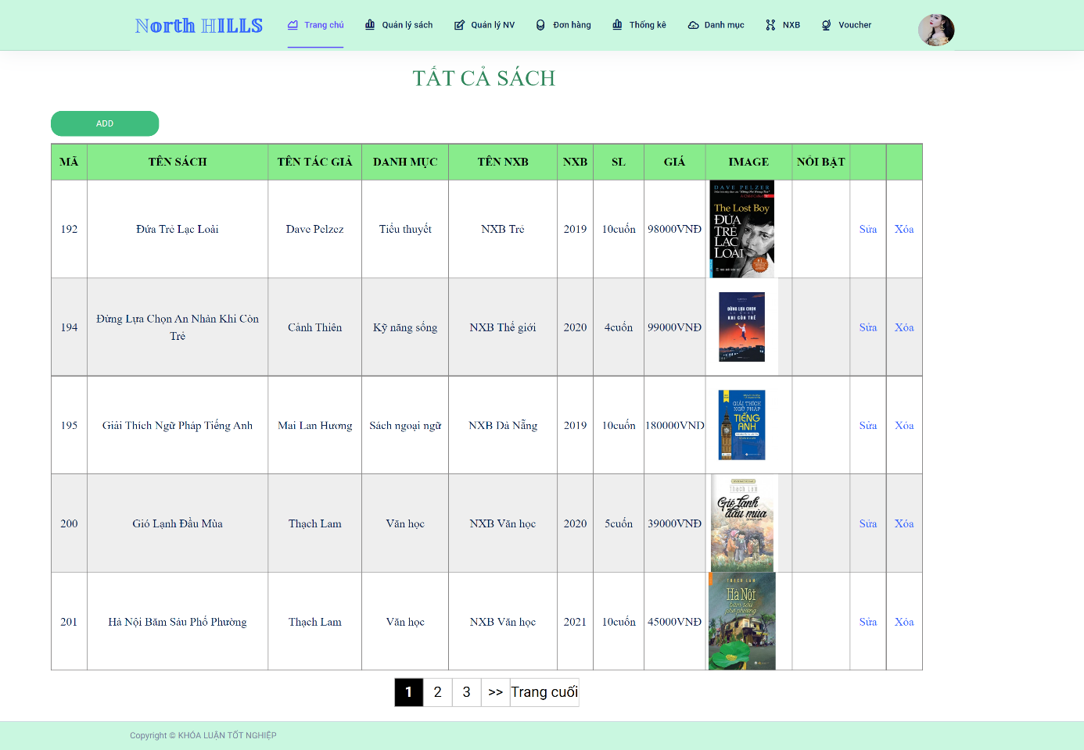

* + - * **Homepage admin**

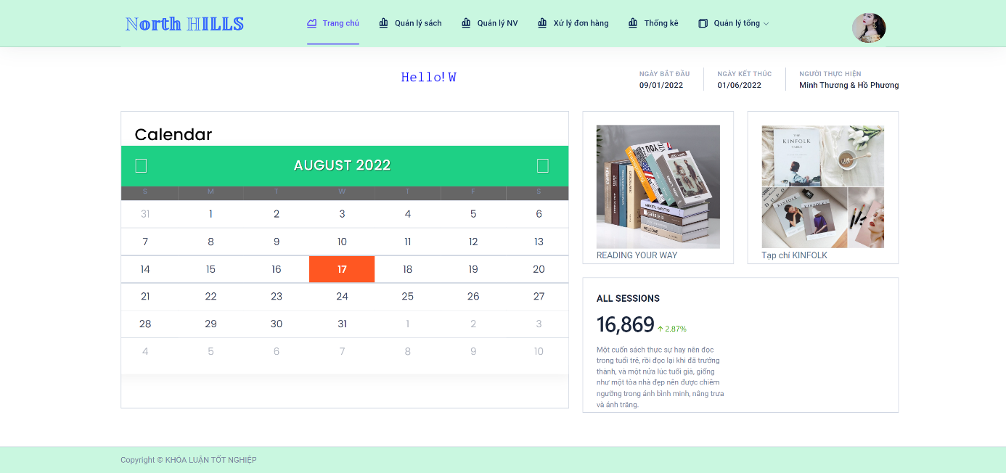

1. **TASK SHEET**

|  |  |  |  |  |
| --- | --- | --- | --- | --- |
| **Task** | **Start time** | **Finish time** | **Implemented** | **Evaluation (%)** |
| **Feasibility Study phase** | | | | |
| Finding identical websites for References | July-09 | July-14 | Nguyen Quang Du | 50 |
| Finalize collected ideas | Do Thai Anh | 25 |
| Idea contribution | Phung Quang Thanh | 25 |
| **Requirement Analysis phase** | | | | |
| Analyze required pages, function | July-15 | July-20 | Nguyen Quang Du | 30 |
| Analyze possible solutions | Do Thai Anh | 40 |
| Finding resources for demo |
| Resources contribution | Phung Quang Thanh | 30 |
| **Design phase** | | | | |
| Sitemap | July-21 | July-23 | Phung Quang Thanh | 30 |
| UI,color,page layouts | Do Thai Anh | 40 |
| Finding references | Nguyen Quang Du | 30 |
| **Development phase** | | | | |
| Create unified CSS | July-23 | August-05 | Do Thai Anh | 40 |
| Responsive web desgin |
| Homepage, Header, Footer |
| Category |
| Detail Product |
| Sign up, Sign in | July-23 | July-28 | Phung Quang Thanh | 30 |
| PHP,SQL intergations |
| Admin page | July-23 | July-28 | Nguyen Quang Du | 30 |
| Contact page |
| Feedback page |
| **Testing phase** | | | | |
| Test Main pages | August-06 | August-07 | Do Thai Anh | 33 |
| Test Admin pages | Phung Quang Thanh | 33 |
| Contribution | Nguyen Quang Dung | 33 |
| **Deployment phase** | | | | |
| Finalize, deloy | August-07 | August-10 | Nguyen Quang Du | 70 |
| Prepare, finalize reports |
| Contribution | Phung Quang Thanh | 30 |